GRANT PURPOSE
The Community Tennis Association Grant is available to those eligible Community Tennis Association’s seeking to start new or expand existing USTA membership based programs.

The USTA/Midwest Section is committed to promoting tennis at the local level. To that end, we offer program grants to assist organizations in initiating or expanding their tennis programming activities. Grants may be used to develop instructional programs and/or organized league play for players of all ages, abilities and populations. Our long-term goal is to help programs become self-sufficient.

GRANT ELIGIBILITY
Financial support will be awarded only to organizations; applications by individuals will not be accepted. Applying organizations must be open to all people, regardless of race, color, creed, religion, gender, national origin, age, disability, sexual orientation, citizenship status, or veteran status.

GRANT AMOUNT
Applicants may apply for up to a $500 grant during the 2016 calendar year. Half (50%) of the grant dollars will be awarded up front and the remaining half (50%) will be awarded after receipt of the Program Grant Evaluation.

APPLICATION DEADLINE
The Community Tennis Association Grant is available to apply for throughout 2016 until funds are exhausted.

GRANT CONTACT
For more information or questions about the Community Tennis Association Grant, please contact Lindsay Ohmer at (317) 669-0475 or Lindsay@midwest.usta.com .

Email completed applications & evaluations or Mail/Fax to:

USTA/Midwest Section
Attn: Lindsay Ohmer
1310 East 96th Street , Suite 100
Indianapolis, IN 46240
Fax: (317) 577-5131
Phone: (317) 669-0475

GRANT GUIDELINES
- To be considered for a grant, the sponsoring organization or program must be or become a USTA Organization Member prior to receiving full funding. To join the USTA as an Organization Member, visit http://www.usta.com/membership (To join by mail, please see page 6 for an Organization Member application). Priority will generally be given to groups offering continuing play or follow-up opportunities and that are open to the public. Program may be visited by a grant evaluator.
- Program must be a registered Community Tennis Association to receive the Community Tennis Association Grant.
- The sponsoring organization or program must show how it plans to become self-sufficient by generating its own funding to continue to offer the program. If the program is conducted under the direction of a park & recreation department or other agency, every effort should be made to allocate the necessary funds into the tennis budget in future years.
- Any program registration fee should be reasonable to encourage participation, be affordable for families in the community, and provisions made for interested participants who lack funds.
- In general, program grants are not meant to support one-day programs or special events – the intent is to support multi-session programs that provide on-going play opportunities.
- All grant applicants should register their programs or events online when appropriate.
- All grant applicants shall provide 2-3 pictures from the program to the USTA/Midwest Section for promotional and public relations uses.
- All grant applicants must submit a complete grant application form that includes a description of the program, program objectives, evaluation methods, and program budget (pages 3-5).
- All grant recipients must return a program evaluation (pages 7-8) within two weeks of the conclusion of the program; if the program is on-going, no later than November 15 of the year in which the grant was awarded. Failure to submit this evaluation may result in the revocation of grant funds awarded.
- A separate application must be submitted for each grant you apply for, and a separate evaluation must be returned for each grant you receive.

.

ORGANIZATION INFORMATION

Sponsoring Organization:
Program Name:
Contact Name:
Mailing Address (Street):
City, State, Zip:
Email:
Website:
Make Check Payable to:

Work Phone |  |  | USTA Organization Membership #:
Home/Mobile Phone |  |  | Are you a 501[c]3?
Fax |  |  | Tax ID #

PROGRAM INFORMATION (“X” ALL THAT APPLY)

Years in existence: | New |  | 1-3 years |  | 4-6 years |  |  |  | 7+ years
Target Audience: | Youth (10 & Under) |  |  | Junior (11-18) |  |  | Collegiate (19-24)
 | Adult (25-49) |  |  | Senior (50 & up)
Target Ability: | Beginner |  | Intermediate |  | Advanced
Facility Type: | School(K-12) |  | College or University |  |  |  |  | Tennis Club
 | Other (list): |  | Public Park

Program Start Date: |  |  | End Date: |  |  |  | Hours/Week:

Number of program participants: |  | 2015 Actual: |  |  |  | 2016 Goal:

Number of tennis courts to be used: |  |  | Number of sites to be used:

Program Fee: | $ | / person |  | Number of scholarships offered:

Grant Amount Requested | $

PROGRAM ADVERTISING & PROMOTION

How will you advertise, promote, and generate publicity for your program? (“X” all that apply)

Flyers |  | Posters |  | Website/Email |  |  | Direct Mail |  | Newspaper |  | Radio |  | Other:
Advertising Period: to

PROGRAM GOALS

(Attach additional sheets as necessary)

Describe the specific activities for which you seek funding:

List your overall goal(s) and specific objectives to help you meet your goal(s):

List your measurable criteria for a successful program and the results you expect to achieve:

Describe your long-term strategies for sustaining this program:

Describe your strategies for retaining participants in this program:

BUDGET FORM

Please use the budget form below as a guideline when applying for a USTA/Midwest Section Tennis Program Grant. You may adapt this form to fit your needs. Your application for financial support will be strengthened by the inclusion of a program budget that illustrates sound financial planning. NOTE: NOT ALL BUDGET ITEMS BELOW WILL APPLY TO ALL APPLICANTS.

Budget for the period |  |  |  |  | to
INCOME |  |  |  | EXPENSES
Source |  |  | Amount | Item |  |  | Amount
Program Fees |  |  |  | Advertising/Promotions
 |  |  |  | Administrative Expenses
Court Rental Fees |  |  |  | Supplies
 |  |  |  | Telephone
 |  |  |  | Postage
Sponsorships |  |  |  | Shipping
 |  |  |  | Printing
 |  |  |  | Website development
In-Kind Support
Court Rental |  |  |  | Program Expenses
Advertising/Radio |  |  |  | Equipment
Other: |  |  |  | Supplies
 |  |  |  | Salary or Wages
Special Events |  |  |  | Certified Pro
Awards Banquet |  |  |  | Instructor(s)
Fundraisers |  |  |  | Program Coordinator
 |  |  |  | Administrative Support
Grants |  |  |  | Education / Training
Government |  |  |  | Recreational Coach Workshop
Foundation |  |  |  | Pro Certification
Corporation
USTA District
USTA Section |  |  |  | Court Rental Fees
USTA National
Other: |  |  |  | Participant Scholarships
Other Income: |  |  |  | Other Expenses:
TOTAL INCOME |  |  |  | TOTAL EXPENSES

For USTA Section Use Only -
Date Received: |  |  |  | Approve |  | Disapprove
District:
Rank:
Comments:

Authorized USTA Section Signature & Date:

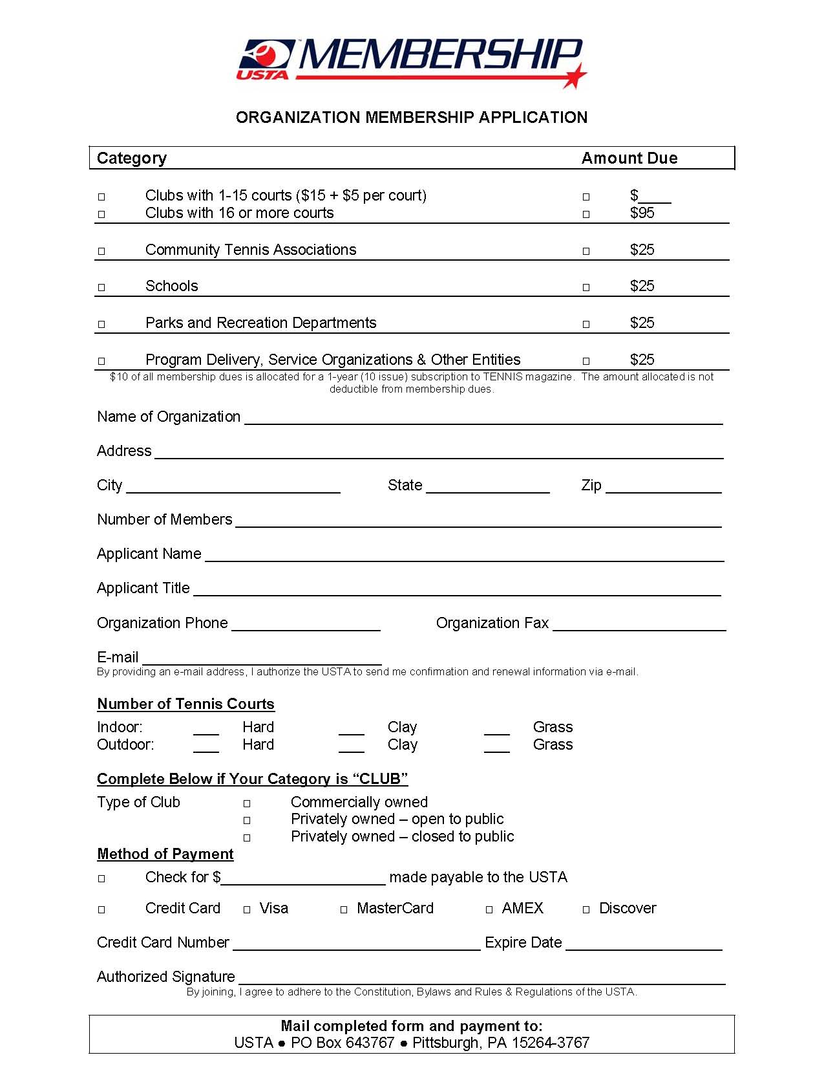
Copy, complete, and mail form with payment to:
Category | 1-Year | 3-Year | 5-Year
Clubs with 1-3 courts | $35 | $100 | $155
Clubs with 4-10 courts | $65 | $185 | $290
Clubs with 11+ courts | $110 | $315 | $495
CTA, School, Park & Rec, Other | $35 | $100 | $155

$10 of all membership dues is allocated for a 1-year subscription to TENNIS magazine. The amount allocated is not deductible from membership dues.
**
**
**
**
**

Evaluation must be completed and returned within two weeks for the conclusion of your program; if the program is on-going, no later than November 15 of the year in which the grant was awarded.

Sponsoring Organization:
Program Name:
Contact Name:
Mailing Address (Street):
City, State, Zip:
Email:
Website:

Work Phone |  |  | USTA Organization Membership #:
Home/Mobile Phone |  |  | Are you a 501[c]3?
Fax |  |  | Tax ID #

PROGRAM EVALUATION

(Attach additional sheets as necessary)

Number of program participants: 2015 Actual 2016 Goal: 2016 Actual:

On the following scale, rate your program's success in achieving your objectives:

 | Poor |  | Fair |  | Good |  | Excellent

Did your program meet the goals & objectives as outlined in your proposal? |  |  | Yes |  | No
Please explain why or why not:

What did you like MOST about your program?

What did you like LEAST about your program?

How would you improve your program?

Do you plan to continue your program next year with local funding/resources? |  |  | Yes |  | No

If YES, describe the funding/resources to be used:

If NO, please explain:

Additional Comments:

NOTE: Please attach photocopies of any local publicity generated by the grant, photos of the program (including names and contact information of individuals in the photos), and any other materials showing the impact this grant had on tennis in your community.

Signature of Program Director & Date:

Email completed evaluations to the Staff “Contact” listed on page 1 or Mail/Fax to:

USTA/Midwest Section
Attn: Lindsay Ohmer

1310 East 96th Street, Suite 100
Indianapolis, IN 46240
Fax: (317) 577-5131
Phone: (317) 669-0475

