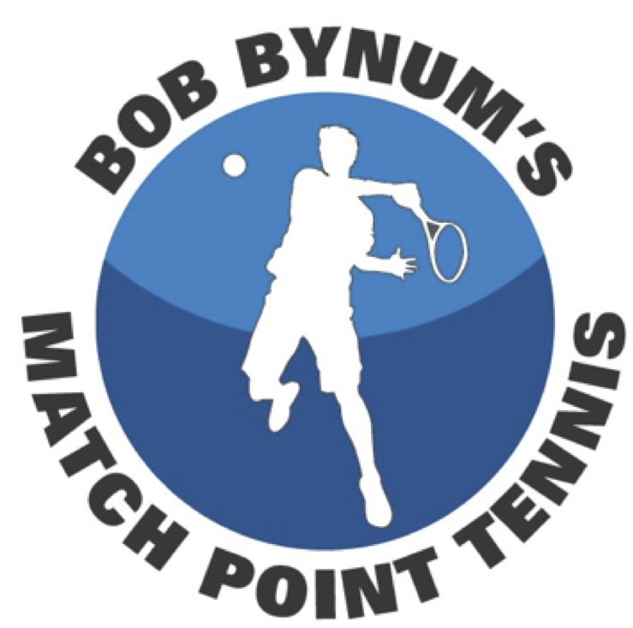

Bob Bynum’s Match Point Tennis
Is Looking For A Few Good Men!

Clifton Racquet Club 1075 Route 46 East Clifton, NJ 07013

Practice for USTA League men’s players at the 3.5 and 4.0 levels! Drills, coaching, and fun, with an emphasis on singles & doubles situations, positioning, and strategy.

This program is intense so come prepared to work!

Thursdays……….…...8:00-10:00pm $250 Per 5-Week Session
Advanced sign-up required at: BBmatchpointtennis.com

For information contact Bob Bynum at:
bob@bbmatchpointtennis.com (973) 477-3368

- Program is offered on a 5-week schedule beginning Oct. 9
- Program is limited to eight players
- Can’t make a week? Send a sub in your place (you collect from the sub )

